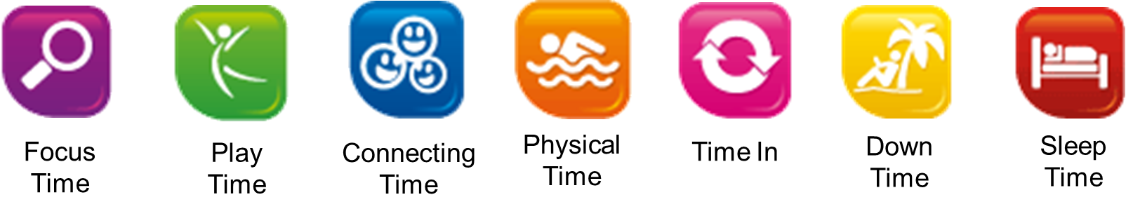



Reflect quietly on your day, week or thoughts in your head. Focus on any images, feelings and thoughts.

Closely focus on tasks or taking on new challenges.

Connect with other people, seeing friends, enjoying family time or talking to people.

Be spontaneous and creative, playfully enjoying new experiences.

Actively moving your body by exercising, playing sports or going for a walk.

Letting your mind wander to recharge the brain. When you are non-focused, without any specific goal, and let your mind simply relax.

Rest to allow the brain time to recover from experiences of the day.